Verification of Professional registration and qualification checks

Policy Number | 22
Version | 1
Policy Contact | Matthew Betteridge
Date Issued | 1st November 2017
Review Date | 1st November 2018
Approved by | OneCall24 Policy Team

As part of the recruitment and ongoing compliance process, agency workers are required to provide proof of current and ongoing valid membership with their professional body.

During the registration process, applicants are asked to confirm whether they are, or have been under investigation by their professional body. If the answer, full details will be obtained at this time.

At point of recruitment, agency workers will be required to supply their original Certificate or a Statement of Entry. Only Original documentation will be accepted. These items will be scanned by One Call 24, signed and dated as original seen and retained within the worker’s file. One Call 24 will ensure that any information presented is cross referenced against other documentation supplied as part of the recruitment in orders to identify any potential discrepancies. Where these are highlighted, they will be raised with the candidate and the appropriate action taken. Where necessary, evidence of annual correspondence from the professional body will be obtained by One Call 24 and retained in the worker’s file.

As well as the original documentation supplied by the agency worker, One Call 24 will also conduct a PIN/Membership check (NMC, GMC, GDC, HCPC) on the information supplied in order to further verify as to whether the worked has current/valid membership. Checks will be carried out at point of registration; immediately prior to any assignment start date (24/48 hours) and every 4 weeks thereafter on workers in long term assignments. Evidence of all checks will be retained in the agency workers file.

Where information is returned on a web check – One Call 24 will ensure that full information is obtained from the agency worker prior to deployment, with the necessary steps taken in line with the restrictions which may be in place on a worker’s PIN. One Call 24 will refer any concerns (where necessary) to the professional body to seek further advice and clarification before placing the candidate into any assignment.
During the initial recruitment, candidates will be notified of their obligation to update One Call 24 with any changes of the status of the professional registration. They will agree to these terms by signing the agency worker handbook.

If an ongoing web check highlights information on a worker’s PIN – One Call 24 will initially contact the agency worker to discuss the findings. Based on the information presented to them, One Call 24 will take a stance on whether to contact the client in order to notify them of any changes. The necessary processes will be followed which may include removing a candidate from their shift until such a time that an investigation is complete of their registration is updates satisfactorily.

Where necessary and requested to, One Call 24 will assist with any ongoing investigations with the professional body, and will expect the agency worker to do the same.
Evidence of all checks and written communications will be retained on file.

As part of the registration process and prior to the deployment of the temporary worker into the authority, One Call 24 will ensure that all relevant professional qualifications have been sufficiently verified.
The worker will be expected to detail on the agency Application Form the professional qualifications obtained. Evidence will then be sort from the temporary worker in the form of the Professional Qualification Certificate. The original item must be provided by the temporary worker, with One Call 24 further verifying this by signing and dating the copies taken of the original certificates as ‘Original Seen’. This will include: the wording ‘original seen’; date for which the original item was seen and scanned and legible signature of the person who saw the original item. The verified copies of the qualification certificates will be retained in the worker’s file.
Should any professional qualification certificate be presented in another language other than English, One Call 24 will ensure that the certificate(s) are translated into the English language by suitable and professional company. Evidence of the original qualification certificate and the translation will be verified as original seen and retained in the worker’s file.

Example of guidance for translation of documentation:
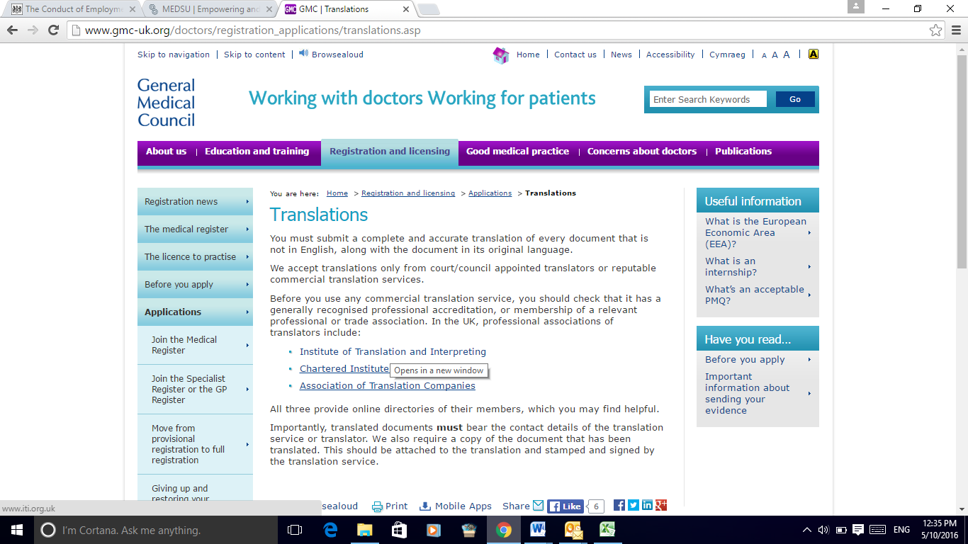

Where a different name or names are present on the supplied professional qualification certificate that do not match those supplied on ID and Right to Work documents , One Call 24 will look to establish a genuine link between the names to further confirm that the certificate(s) provided by the worker is genuinely theirs. Sufficient proof of name change will be sort in the form of either: marriage certificate; divorce certificate; change of name deed poll or any other legal document which can sufficiently prove a change in the worker’s name. Proof of name change documents must be original seen, with verified copies retained in the worker’s file.
One Call 24 will cross check all professional qualifications supplied next to the details presented within the application form and any other vetting correspondence.
In line with the framework guidance, One Call 24 will ensure that agency workers have the necessary professional qualifications.

Consultant | MBBS or equivalent medical qualification;  MRCP (UK) or other relevant Royal College Postgraduate Examination equivalent; and  where required for the individual Assignment or Call-off Contract:  - Registered on relevant Professional Body Specialist Register; and  - Section 12 (2) Mental Health Act 1983 approval
Associate Specialist | MBBS or equivalent medical qualification;  MRCP (UK) or other relevant Royal College Postgraduate Examination equivalent; and  where specifically required for the individual Assignment or Call-off Contract:  - Section 12 (2) Mental Health Act 1983 approval
Specialty Doctor (formerly Staff Grade) | MBBS or equivalent medical qualification;  MRCP (UK) or other relevant Royal College Postgraduate Examination equivalent; and  where specifically required for the individual Assignment or Call-off Contract:  - Section 12 (2) Mental Health Act 1983 approval
Registrar SP4 | MBBS or equivalent medical qualification.
Registrar SP3 (formerly SpR grade) | MBBS or equivalent medical qualification.
Registrar SP2 | MBBS or equivalent medical qualification.
Registrar SP1 | MBBS or equivalent medical qualification.
Foundation Year 2 (formerly SHO grade) | MBBS or equivalent medical qualification;  UK Medical practitioners to have at least 12 months’ experience at FHO1 grade or equivalent; and  Overseas Medical practitioners to have at least 6 months experience in the UK.
Foundation Year 1 (formerly HO or PrHO grade) | MBBS or equivalent medical qualification;  UK graduates to have completed the PrHO or FHO1 year; and  Overseas graduates to have completed the PrHO or Intern year overseas.
Sessional or ‘locum’ General Practitioner (‘GP’) | MBBS or equivalent medical qualification;  MRCGP (UK) or other relevant Royal College Postgraduate Examination equivalent;  Registered on relevant Professional Body’s GP Register; and  Registered on a relevant NHS Trust’s Performer’s List
Locum General Dental Practitioner | BDS or BChD or equivalent dental surgery qualification  Registered on relevant Professional Body’s Register; and  Registered on a relevant NHS Trust’s Dental Performer’s List
    - Health Careers (see www.healthcareers.nhs.uk/explore-roles ); and
    - Recruitment to medical specialty training in England (see www.specialtytraining.hee.nhs.uk/ ); and
    - the relevant associations. colleges, Royal Colleges and faculties thereof:
Organisation name | Website address
National Association of Sessional GPs | www.nasgp.org.uk
College of Emergency Medicine | www.rcem.ac.uk
Royal College of Anaesthetists | www.rcoa.ac.uk/
Royal College of General Practitioners | www.rcgp.org.uk/
Royal Society of Medicine | www.rsm.ac.uk/
Royal College of Obstetricians and Gynaecologists | www.rcog.org.uk/
Royal College of Ophthalmologists | www.rcophth.ac.uk/
Royal College of Paediatrics and Child Health | www.rcpch.ac.uk/
Royal College of Pathologists | www.rcpath.org/
Royal College of Physicians | www.rcplondon.ac.uk/
Royal College of Psychiatrists | www.rcpsych.ac.uk/
Royal College of Radiologists | www.rcr.ac.uk/
Royal College of Surgeons of England | www.rcseng.ac.uk/
Royal Society of Tropical Medicine and Hygiene | www.rstmh.org
Faculty of Dental Surgery | www.rcseng.ac.uk/fds
Faculty of General Dental Practice | www.fgdp.org.uk
Faculty of Intensive Care Medicine | www.ficm.ac.uk
Faculty of Occupational Medicine | www.fom.ac.uk/
Faculty of Pharmaceutical Medicine of Royal College of Physicians | www.fpm.org.uk
Faculty of Public Health | www.fph.org.uk
Faculty of Sexual & Reproductive Healthcare | www.fsrh.org/default.asp
Faculty of Sport and Exercise Medicine | www.fsem.ac.uk
In the case of Other Clinical staff:
    - Health Careers (see www.healthcareers.nhs.uk/explore-roles ); and
    - NHS Employers national job profiles:
      - Allied health professionals (see www.nhsemployers.org/your-workforce/pay-and-reward/pay/job-evaluation/national-job-profiles/allied-health-professionals );
      - Emergency services staff (see http://www.nhsemployers.org/your-workforce/pay-and-reward/pay/job-evaluation/national-job-profiles/emergency-services );
      - Health science services staff (see http://www.nhsemployers.org/your-workforce/pay-and-reward/pay/job-evaluation/national-job-profiles/health-science-sevices );
      - Professional manager (clinical, clinical technical service) (see http://www.nhsemployers.org/your-workforce/pay-and-reward/pay/job-evaluation/national-job-profiles/other ); and
    - the relevant associations. colleges, Royal Colleges and faculties thereof:
Organisation name | Website address
British Association of Art Therapists | www.baat.org/
British Association of Clinical Dental Technology | www.bacdt.org.uk/
British Association of Dental Therapists | www.badt.org.uk/
British Association for Drama therapists | www.badth.org.uk/
British Association for Music Therapy | www.bamt.org/
British Association of Prosthetists and Orthotists | www.bapo.com/
British Dietetic Association | www.bda.uk.com/
College of Occupational Therapists | www.cot.org.uk/
College of Paramedics | www.collegeofparamedics.co.uk/
College of Operating Department Practitioners | www.codp.org.uk/
Institute of Biomedical Scientists | www.ibms.org/
Royal College of Speech and Language Therapists | www.rcslt.org/
Royal Pharmaceutical Society of Great Britain | www.rpharms.com/
The British Academy of Audiology | www.baaudiology.org/

Where any concerns arise over the professional qualification or professional registration evidence supplied, One Call 24 will contact the educational body/relevant body to further confirm that the information supplied is true and correct.

NMC –
https://www.nmc.org.uk/
Address: 23 Portland Pl, London W1B 1PZ
Phone: 0207 637 7181
Email: complaints@nmc-uk.org

GMC
http://www.gmc-uk.org/
Address: 350 Euston Rd, London NW1 3JN
Phone: 0161 923 6602
Email: practise@gmc-uk.org

GDC
http://www.gdc-uk.org/Pages/default.aspx
Address: 37 Wimpole St, London W1G 8DQ
Phone: 0207 167 6000
Email: info@dentalcomplaints.org.uk

HCPC
http://www.hcpc-uk.co.uk/
Address: Park House, 184 Kennington Park Road, London SE11 4BU
Phone: 0845 300 6184
Email: ftp@hcpc-uk.org

NHS Protect
Address: Complaints NHS Protect, Skipton House, 80 London Road, London, SE1 6LH
Phone: 0207 895 4500
Email: complaints@nhsprotect.gsi.gov.uk

Examples of web tools used for checking current/valid membership:

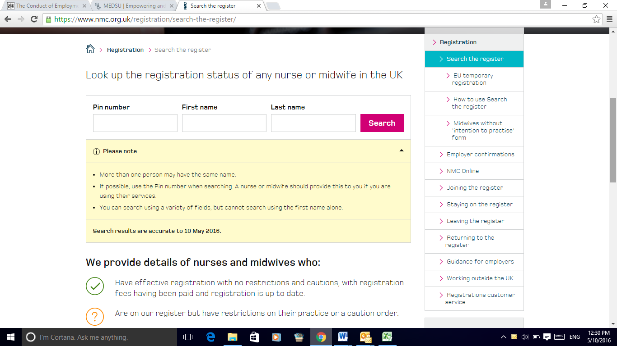

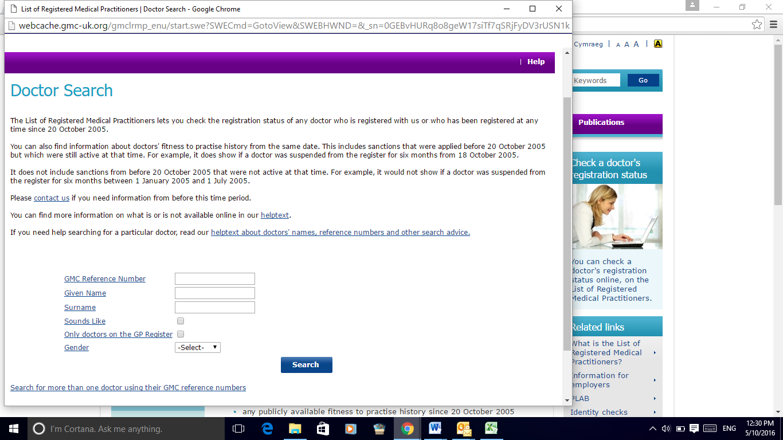

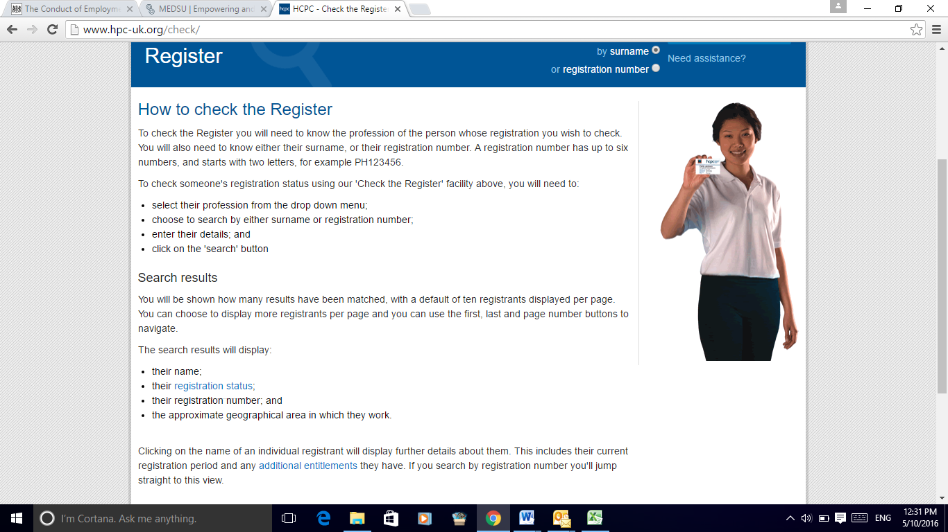

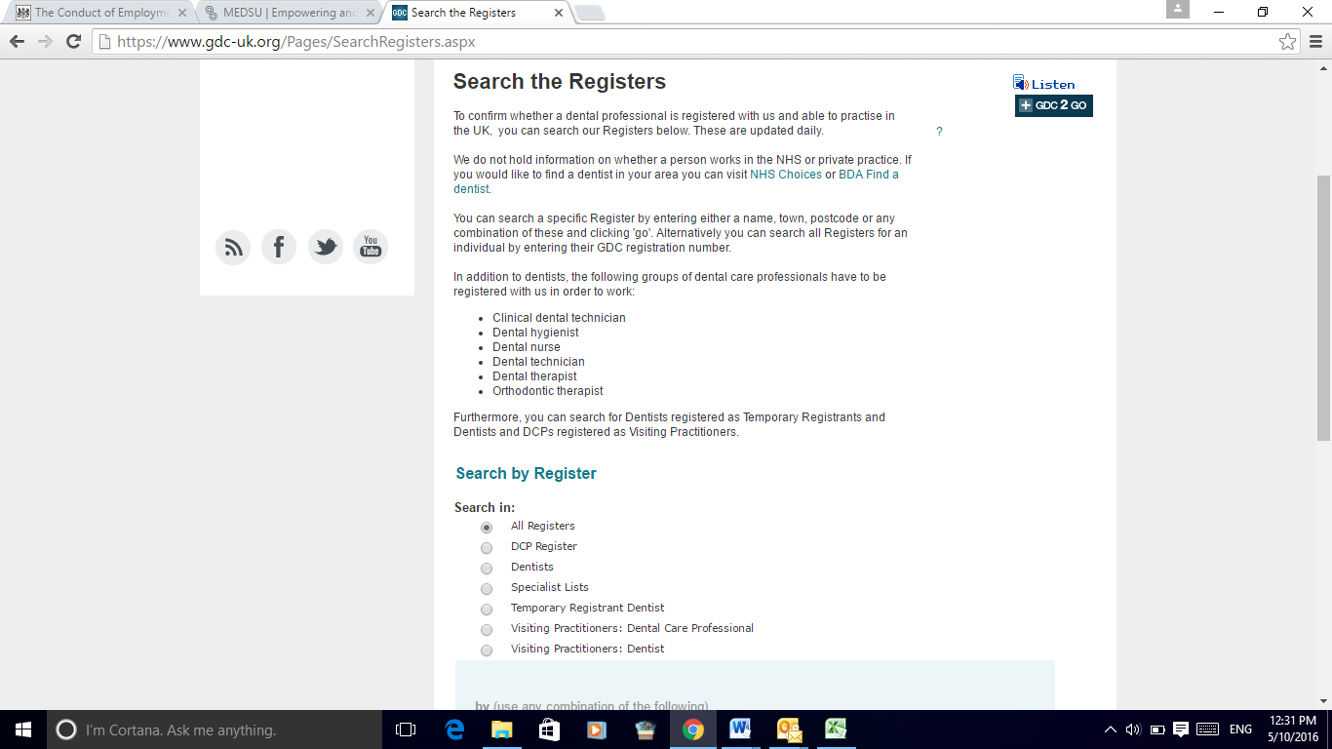

At all time, One Call 24 will comply with latest NHS Employment Check Standards (see www.nhsemployers.org/your-workforce/recruit/employment-checks/nhs-employment-check-standards/professional-registration-and-qualification-checks).

